11th International Best Practice Competition 2025

SPONSORSHIP AGREEMENT FORM

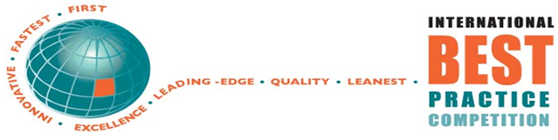

Principal Contact Details:
Name: | Click or tap here to enter text.
Position: | Click or tap here to enter text.
Organisation: | Click or tap here to enter text.
Address: | Click or tap here to enter text.
Contact No.: | Click or tap here to enter text.
Email: | Click or tap here to enter text.

Sponsorship Package:

Type of Sponsorship | Fee (US$) | Tick One Option
Platinum | 10,000 | ☐
Gold | 3,000 | ☐
Silver | 2,000 | ☐

If Gold has been selected, which award do you wish to sponsor?
Sponsorship for Award | Tick One Option
Organisation-Wide Innovation Award (OWIA) | ☐
Global Benchmarking Award (GBA) | ☐
Environmental, Social, & Governance (ESG) Excellence Award | ☐

Page 1 of 2

11th International Best Practice Competition 2025

SPONSORSHIP AGREEMENT FORM

If Silver has been selected, which award category do you wish to sponsor?
Award Category | Tick One (1) Award Category You Wish to Sponsor | Tick Two (2) Webinars You Wish to Sponsor in Addition to Your Award Category
Leadership | ☐ | ☐
Governance | ☐ | ☐
Social Responsibility | ☐ | ☐
Environmental Sustainability | ☐ | ☐
Strategic Planning and Deployment | ☐ | ☐
Performance Measurement and Management | ☐ | ☐
Customer and Market Focus | ☐ | ☐
Design of Products/Services | ☐ | ☐
Supplier Relationships and Partnerships | ☐ | ☐
Education, Training, Development, and Learning | ☐ | ☐
Employee Teams, Empowerment, Motivation, Satisfaction | ☐ | ☐
Employee Health, Safety, and Wellbeing | ☐ | ☐
Workforce Planning, Recruitment, and Retention | ☐ | ☐
Process Management and Improvement | ☐ | ☐
Change Management | ☐ | ☐
Innovation Systems and Approaches | ☐ | ☐
Innovation Projects | ☐ | ☐
Management of Assets | ☐ | ☐
Risk Management | ☐ | ☐
Digital Transformation | ☐ | ☐
Automation and Technology | ☐ | ☐
SME Award (50 employees or less) | ☐ | Not applicable
Pioneer Prize(s) for organisation that achieves the most 4, 5 and 6 above Star-Rated Best Practices | ☐ | Not applicable

On submission of the Sponsorship Agreement form to sponsorship@coer.org.nz, the Competition Organisers will contact you for further information so your organisation can be immediately profiled as a sponsor in all communications. Payment of the Sponsorship Fee is due within 14 days of receiving the Sponsorship Agreement form. In the unlikely circumstance that the Competition does not take place and cannot be rescheduled, the Sponsorship Fee will be reimbursed in full.
Page 2 of 2

